(Approx. 1028 words)

What’s New in Microsoft Office 2016
By Nancy DeMarte, 1st Vice President, Sarasota Technology User Group, FL
May 2016 issue, Sarasota Technology Monitor
www.thestug.org
ndemarte (at) verizon.net

Last September, Microsoft kept to its usual three-year schedule of issuing a new edition of Office when it released Office 2016. The questions always are, What is different in this edition? Is it worth upgrading? Here are a few of the features you will find in this new Office. Maybe they will answer these questions for you.


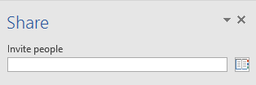
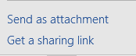
The basic commands and toolbars (ribbons) have not changed much from the last few versions. But Microsoft does often streamline and refine processes, and 2016 is no exception. The new version makes more use of One Drive, the Microsoft cloud, in order to make sharing Office files easier. Click the Share button on the top right of the ribbon to open the Share sidebar. If your file is not saved to OneDrive, you will be instructed to save it there. Then type an email address or choose one from your address book in the “Invite people” box and choose either “Send as attachment” or “Get a sharing link.” This process is generally the same as in Office 2010 and 2013 except it is much easier to access.


Searching is easier in Office 2016, too, with the new “Tell me what you want to do” box above the ribbon in all the Office programs. When you click in the box, you get suggestions for things you might want to do, based on the program you are using and what you’re doing with it, or you can type in a new search topic. I think this feature needs a bit more work, but once improved, can be very useful.

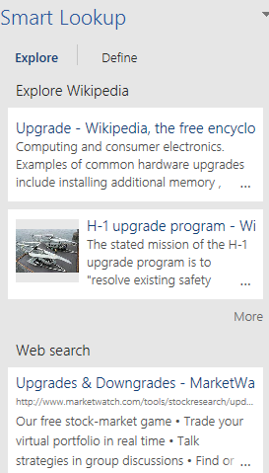
Another feature that has been improved in Office 2016 is called Insights, an expanded version of Smart Lookup. Right click a word or phrase in your document or presentation and choose Smart Lookup from the dropdown menu to open a sidebar which includes the definition, pronunciation (written and audio), explanations and examples from Wikipedia, and relevant results of a Bing web search. This feature is much more extensive than the earlier Smart Lookup. In the example, I right-clicked the word Upgrade and got these results. (This is only part of the list.) This feature is found in Word, PowerPoint, Outlook, and Excel 2016.

Individual Office programs also got a few upgrades, too. Excel got several new chart types, with intriguing names like Waterfall and Sunburst. The new Forecasting feature predicts trends based on the current data and displays them in a Trend chart.

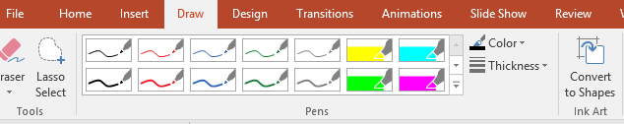
Office 2016 also offers a few brand new features. Anyone who uses a touch-enabled laptop or device with Office 2016 or Office mobile apps installed can use the new Ink Notation feature in Word, Excel, and PowerPoint. Click or touch the new Draw tab in the ribbon; choose a color and pen size and draw on the screen. Make a mistake? Use the eraser. You can highlight words using the Ink toolbar, too. PowerPoint also allows you to convert your ink drawings into shapes.

PowerPoint and Word 2016 have a fascinating new feature, introduced in Office 2013, that allows you to remove the background of a photo. (See example.)



To remove the background, insert a photo into Word or PowerPoint, select it, and click the Picture Tools Format tab. On the left end of the Format ribbon, click Remove Background. If needed, you can adjust the size of the area inside the picture or mark areas to keep or discard. Then click “Keep Changes” to view a copy of the photo with the background removed, leaving the original safe in your Pictures folder.
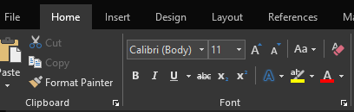
Another new feature in 2016 is the Black theme: a black background with white text, which is considered easier to read by some people with vision difficulties. Office 2013 featured the Colored theme, where each Office app had its own background color: green for Excel, blue for Word, orange for PowerPoint, and so on. This is still the default color theme. The other choices are Dark Gray and White. To change the background color, open any Office 2016 program, click File – Account, click the arrow next to Office theme and make your choice. This will change the background for all Office programs.

Every year, it seems Microsoft offers new temptations for Office users to move to one of the subscription versions of Office, called Office 365. Office 2016 contains some new features which are only available to Office 365 subscription users. For example, PowerPoint has two of these features: Morph and Designer. Morph is a special kind of transition, where a shape or group of text can be set to move across the screen. Designer offers design ideas for photos which appear in slides, such as arrangement on the page or coloration. It can be found on the right end of the Design tab in PowerPoint. It does not work yet with all photos; a photo must be 200x200 or higher resolution.
Only Office 365 users of Word or PowerPoint 2016 can collaborate on projects in real time. Multiple editors can edit a file and watch each other’s editing changes as they happen through the new Collaborative Editing feature. This is a popular feature with the Business version.

A recent trend in Office improvements is that they often occur periodically through regular monthly updates if you have a subscription version. I noticed that my Office 365 Home subscription introduced some of the features of Office 2016 before my applications began being labeled Office 2016.

If you are thinking of trying Office 2016, you might wonder if it will open all those documents and spreadsheets you created in earlier Office versions. If you have files created with Office 2007, 2010, or 2013, you will find them completely compatible with 2016. If you have files created with earlier versions, you can get a free Compatibility Pack at the Microsoft website, which will make older Word, Excel, and PowerPoint files compatible with Office 2016. Searching for “Compatibility Pack for MS Office 2016” will lead you to the download page in a hurry.

